HTML Ch. 1 & 2 Your Turn 3

You will be creating a site of your choice but will need to follow the instructions in the book for the Your Turn 3 Dog Hall of Fame site to complete it. Begin this site by creating your site folders.

1. In your H: Drive, ch2 folder, create a site folder and subfolders for the Your Turn 3: Your Choice website
   1. A close up of text on a white background

      Description generated with high confidenceSite folder – **si _yt3_name_02**. However, you should change the part in red to a title appropriate for your topic.
   2. Subfolders
      1. css
      2. images
      3. media
      4. template
      5. planning
      6. submissions
2. Read this paragraph from page 48 of the HTML5 & CSS3 Book:
3. Create a Word document to answer the following questions in. Save it in the planning folder as: **p# lastname firstname yt3 ch2 plan**
   1. Select a topic of your own
      1. Determine a purpose for your site, such as a Dog Hall of Fame
      2. What type of content you would like to include
      3. Title of your Webpage
      4. 3 Sub categories such as working dogs, hero dogs, and companion dogs
4. Research your topic and the 3 categories you will be using. Save a minimum of 3 articles for each category in the planning folder for future reference.
5. Add to the **p# lastname firstname yt3 ch2 plan** document by writing one paragraph for each category based on the articles you found. One paragraph equals a minimum of 4, high-school level sentences. Save the document again and close.
6. From the book, follow the instructions to create the basic web page for your site.
   1. Save the file in the site folder as: **si_yt3_name_index_02.html.** Change the red text to the name of your site.

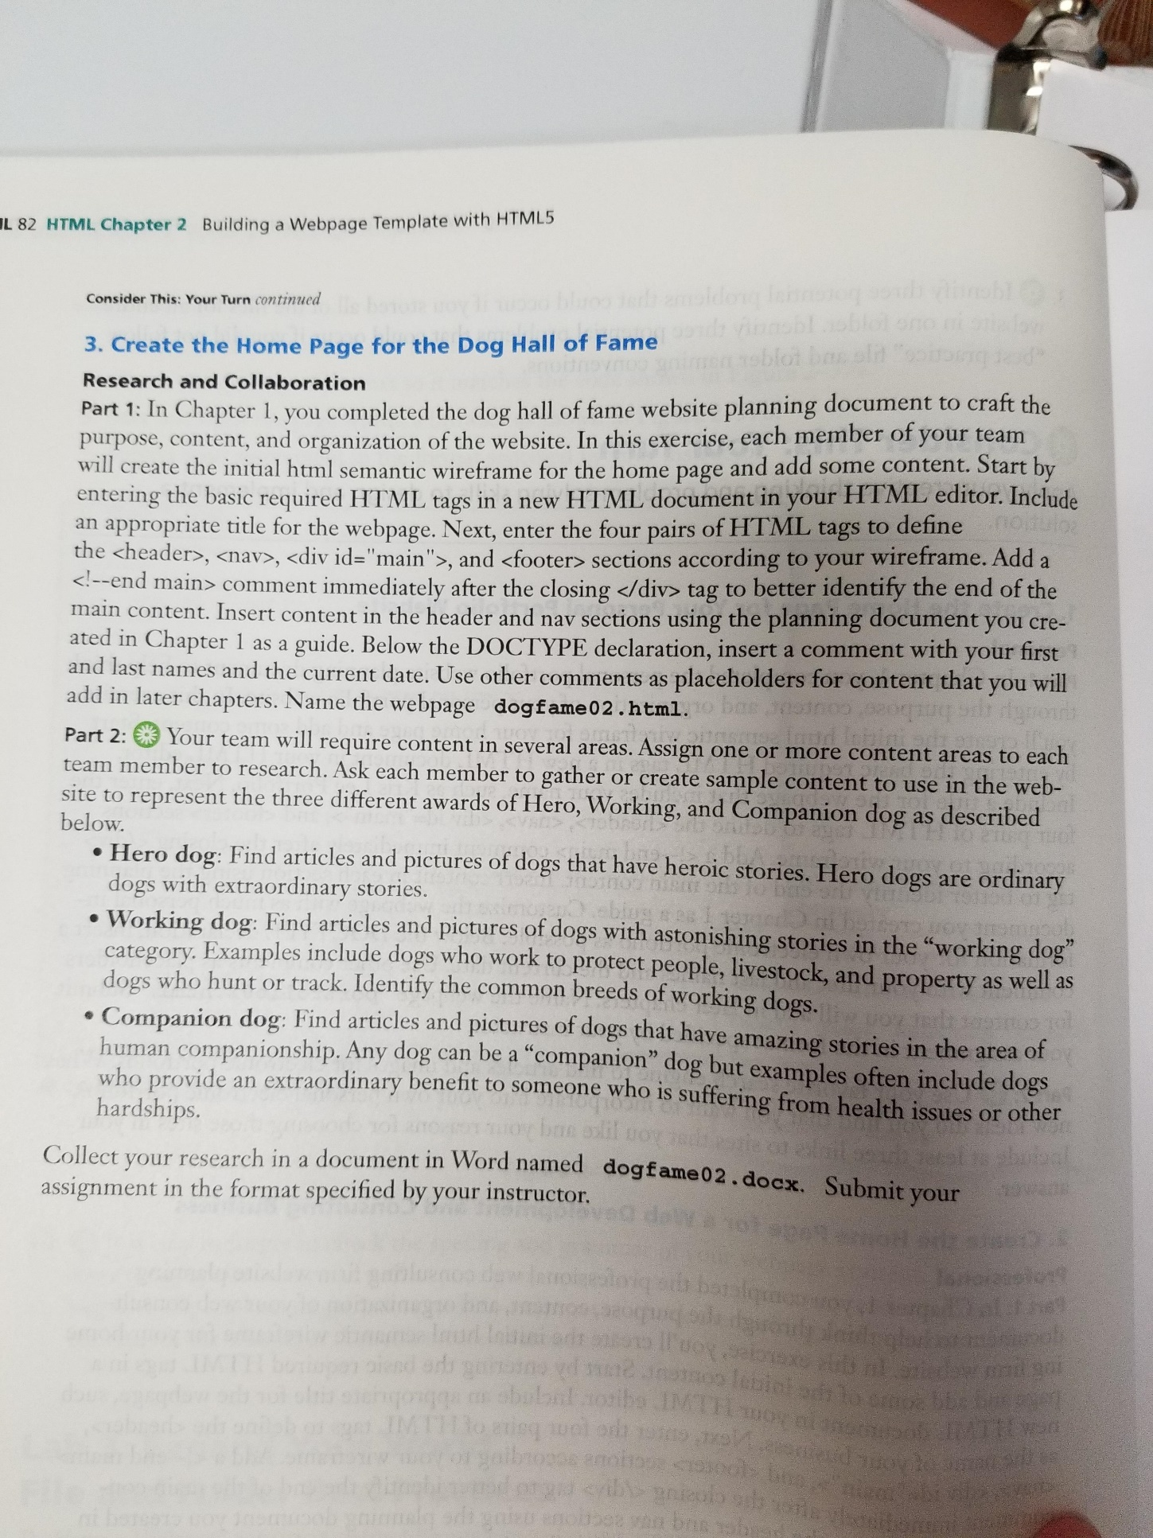

1. Example of comments for content:

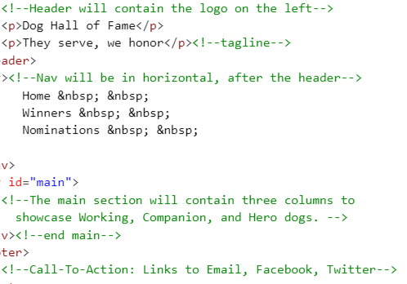

1. Use the [http://validator.w3.org/ site](http://validator.w3.org/%20site) to validate your assignment.
2. Open a new Word document.
   1. Save in the submissions folder as **p# LastName FirstName yt3 ch2 submissions.docx**
   2. Add the following *READABLE* screen snippings:
      1. Open site folder. Make sure you can see the address bar at the top of the window and all the folders.
      2. Index page code
      3. Index page browser view
      4. Index page validation
3. Create a zip file of the cycle site folder.
   1. Right click on the folder, select “send to”, then Compressed (zipped) folder. The zipped folder will appear in the same folder as the original.
   2. Move the zipped folder into the submissions folder
4. Copy the site folder to your flash drive, OneDrive, or other back up storage
5. Submit the following documents in Canvas:
   1. **p# LastName FirstName yt3 ch2 submissions.docx**
   2. Zipped **si_yt3_name_02** folder